Cisco Duo
Multi Factor Authenticator

Contents
Introduction 3
Enrolment – Duo Mobile App. 4
Enrolment – Phone call 8
Manage your second factor device 13
1. Add a device 16
2. Change your device 17
Test Portal 22
Troubleshooting. 22
Appendix 24

Introduction

All Central Bank Portal users must enrol for Cisco Duo in order to access the Portal. Users that are unable to login to the Portal will get a ‘Not enrolled in Duo’ message and will need to email <onlinereturns@centralbank.ie>. You will then receive an email from <no-reply@duosecurity.com> that will contain a link for enrolment. This link will be valid for 30 days.

- There are two enrolment options.
- You will need a PC and a Phone to enrol.
- For greater security and convenience, we recommend that you use the ‘Duo Mobile’ app method and download the app prior to beginning the enrolment process.
- The ‘Duo Mobile’ app is free and you will not have to pay a subscription to use the app.

Please follow the guidance below for enrolling and logging in. If your enrolment link has expired please email onlinereturns@centralbank.ie. You will be sent a new enrolment link which will be valid for another 30 days.

Enrolment – Duo Mobile App.
Step 1:
When registering for a Portal account new users will need to enrol for Cisco Duo. Users will receive the below email from Duo Security. Please click on the link to enrol.
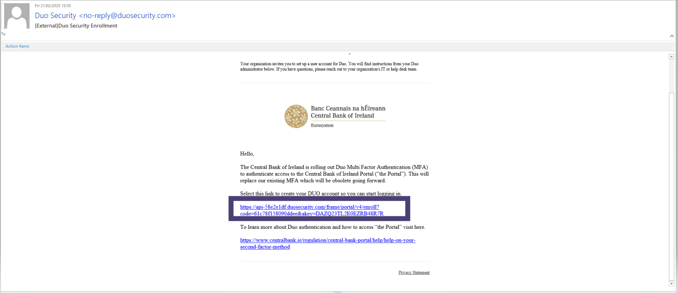

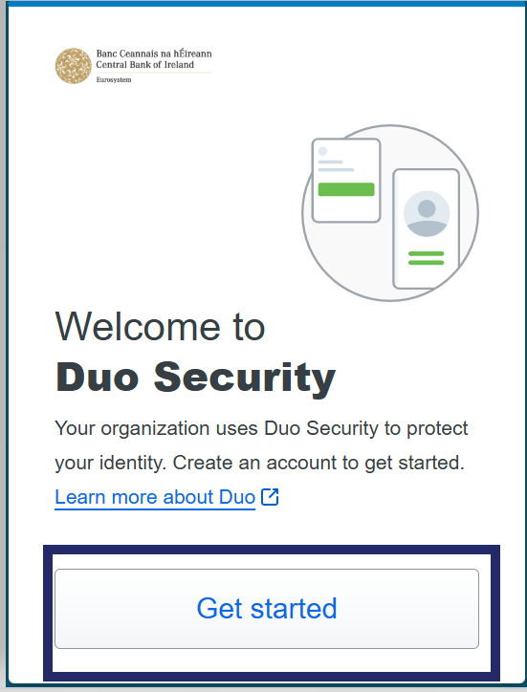
Step 2:
A separate window will open as per the screenshot, select ‘Get Started’.
Step 3:
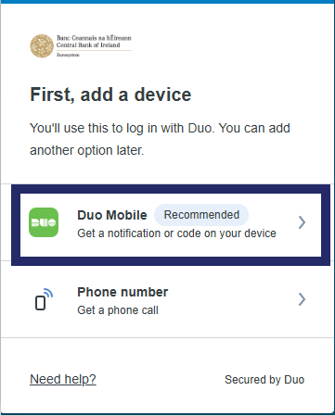
After you select ‘Get Started’
you will see the ‘First, add a device’ page.
Please select the Duo mobile option.

Step 4:
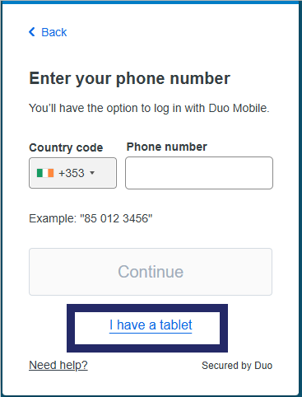
Please select ‘I have a tablet’
to enrol using the Duo mobile app. You do not need to input your phone number at this step.

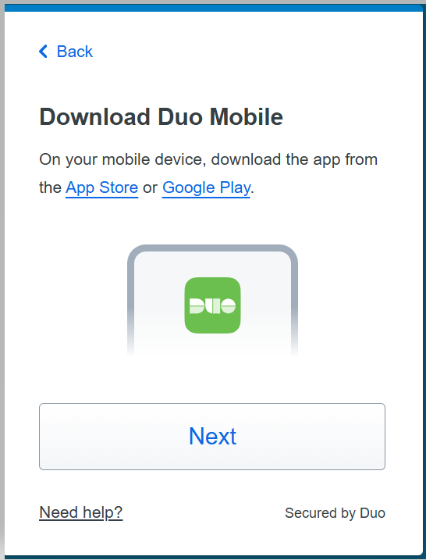
Step 5:
Select ‘Next’ once the Duo Mobile app is downloaded and installed on your phone.

Step 6:
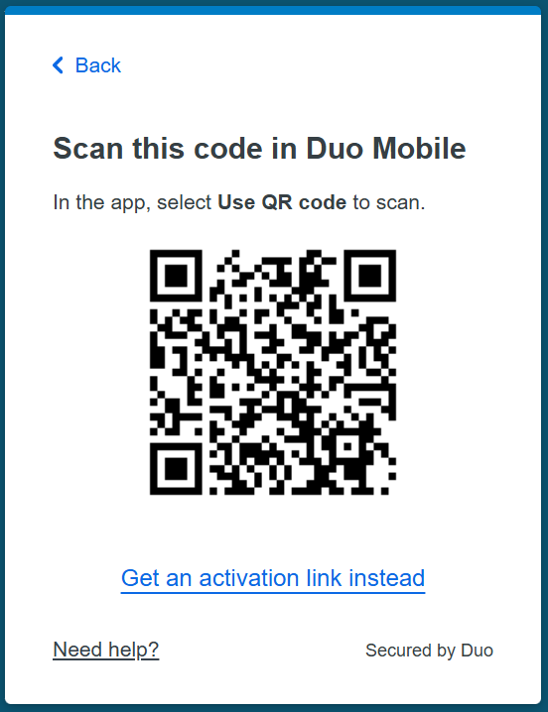
Using the DUO app scan the QR code from within the app. This completes the association of the Duo phone-app-account to your device. Set up is then completed.

Step 7:
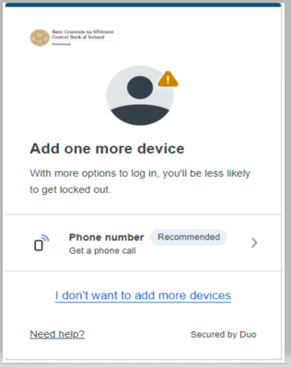
You are able to add another device
if you wish or you can select
‘I don’t want to add more devices’.

Step 8:
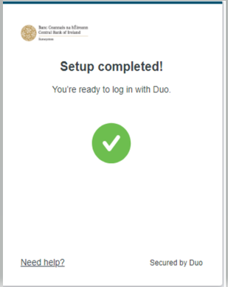
You will see the ‘Setup completed’
screen once registered. You have successfully registered. You will be able to log in using Duo.

Enrolment – Phone call
This section describes the steps taken to enrol if the preferred authentication method is by receipt of a phone call.

Step 1:
Users will receive the below email from Duo security. Please click on the link to enrol.

Step 2:
When you click on the link in the email–
A separate window will open as per the
screenshot, select ‘Get Started’

Step 3:
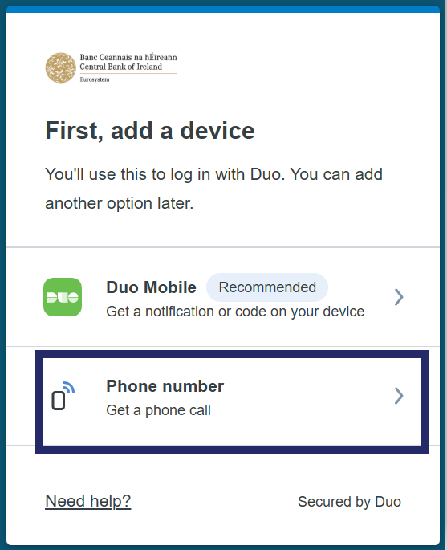
Please select the ‘Phone number’ option.

Step 4:
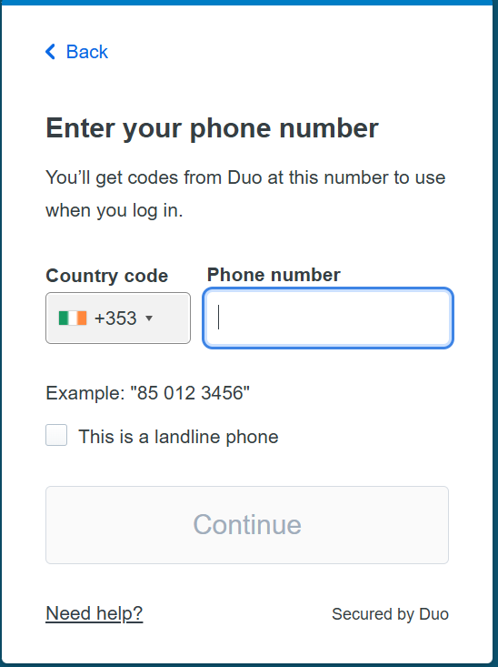
Please select the ‘Phone number’ option.

Step 5:
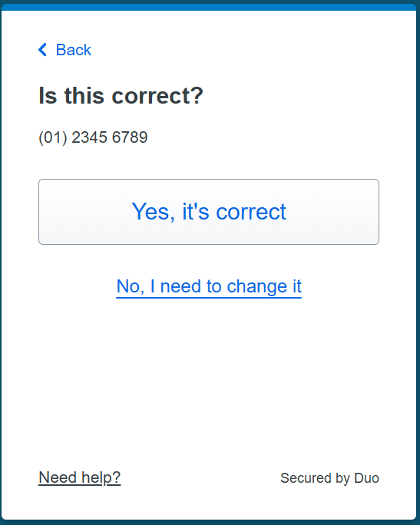
You must confirm your details are correct by clicking ‘Yes, It’s correct’.

Step 6:
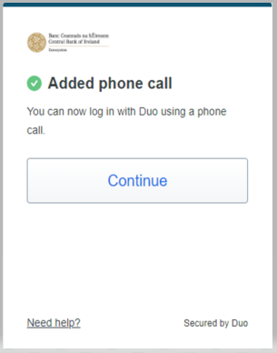
Set up is completed and you will see on the screen that the phone call has been added. Please select ‘continue’.

Step 7:
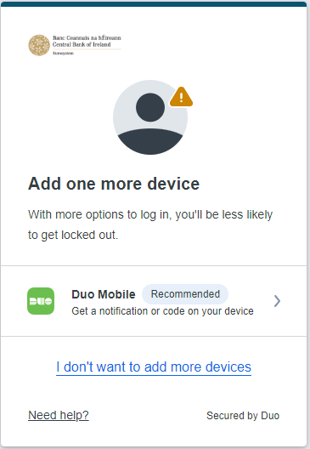
You are able to add another device if you wish or you can select ‘I don’t want to add more devices’.

Step 8:
You will see the ‘Setup completed’
screen once registered.
This indicates you have successfully registered and will be able to log in using Duo.

Manage your second factor device
This section describes the steps that users can take to change or add authentication devices.
To access the Duo self-service portal follow the steps below.
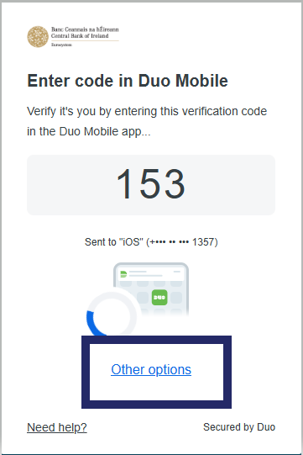
Step 1:
When you login to the Central Bank portal, enter your person code and password and click sign in. You will then be met with the below screen. Click ’Other Options’.

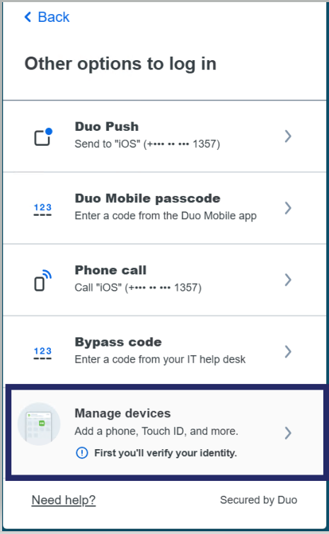
Step 2:
Select ‘Manage Devices’.

Step 3:

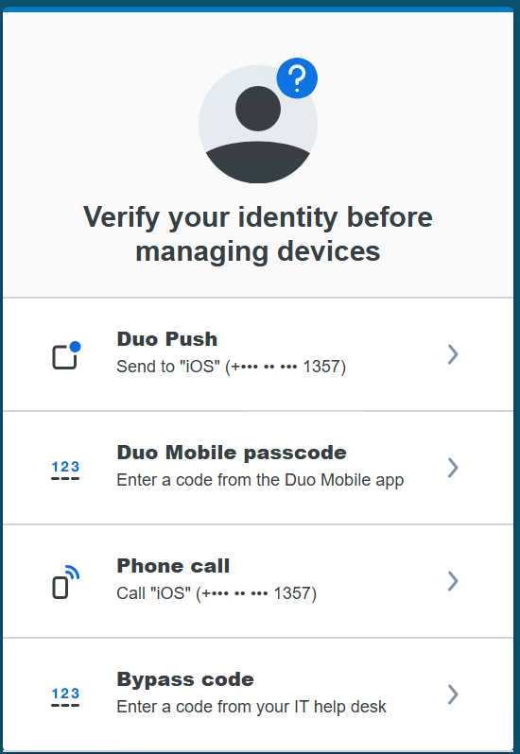
You will need to verify your identity before you are able to manage your devices. Please select the option that you currently authenticate with to access the ‘Manage devices’ page.

Step 4a:
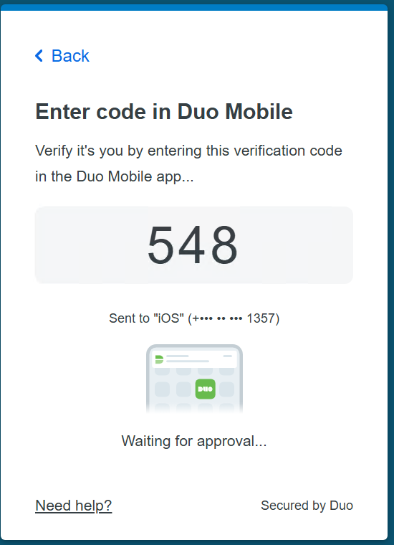
If you select the ‘Duo Push’ option from the above screenshot, a code will appear on the screen which you enter into the Duo Mobile app to verify it’s you.

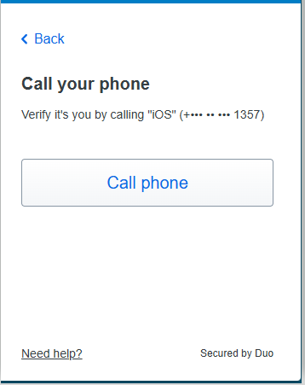
Step 4b:

If you selected the ‘Phone call’ option click ‘Call phone’ and your phone will ring. Please press the number ‘1’ on your keypad to verify it’s you.

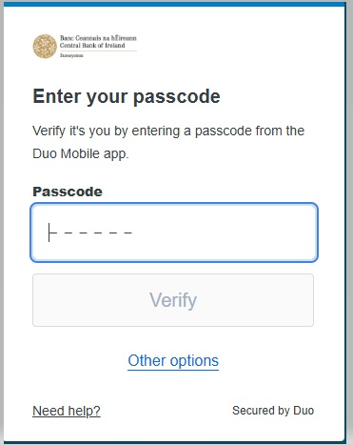
Step 4c:

If you selected ‘Duo Mobile passcode’ enter the 6 digit passcode that appears in the ‘Duo Mobile’ app to verify it’s you.

- Add a device

Step 1:

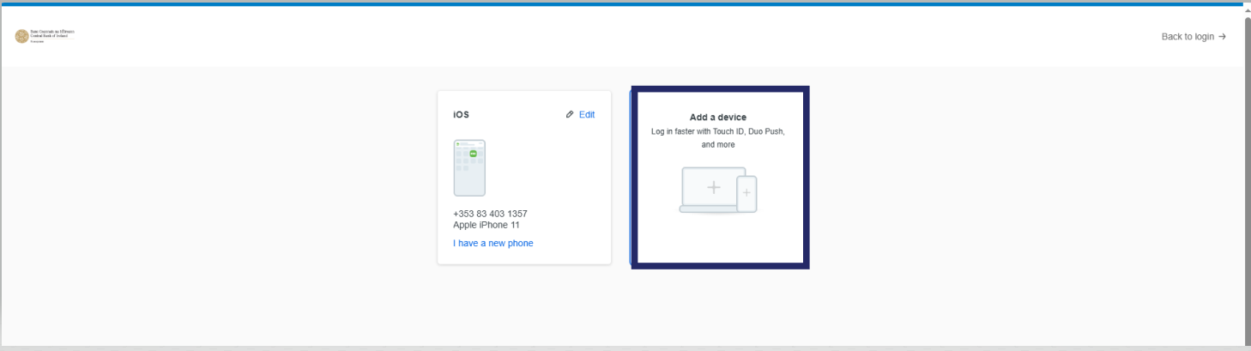
If you are trying to add a new device or change your phone number select ‘Add Device’.

Step 2:
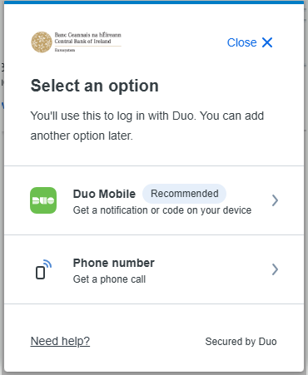
You can then select the option of which method you want to add.

Step 3:
Complete the process by following steps 3 to 8 under Enrolment – Duo Mobile App

- Change your device

Step 1:

If you have a new phone and want to update your Duo mobile app from your old phone to your new phone please click ‘I have a new phone’.
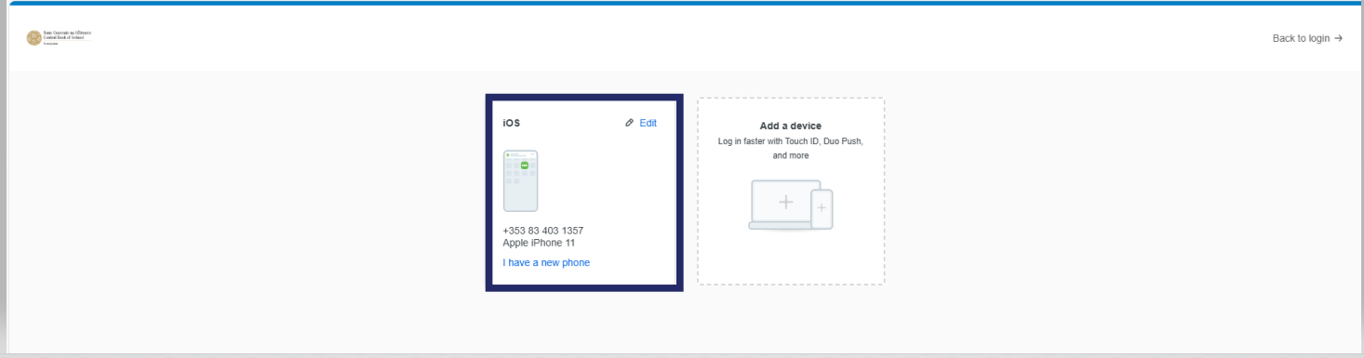

Step 2:
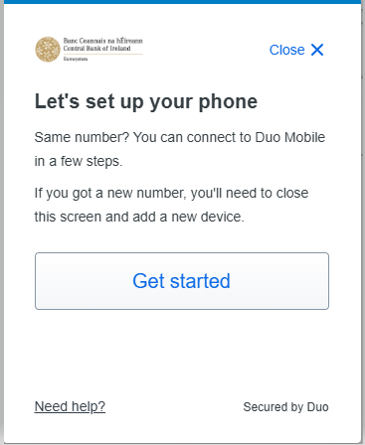
When you click ‘I have a new phone’ click get started.

Step 3:

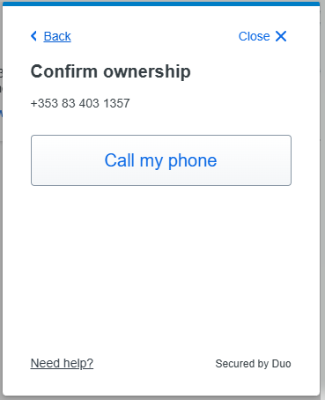
You will need to confirm ownership so click ‘Call my phone’.

Step 4:
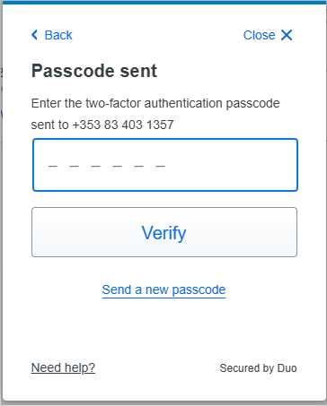
Answer the phone call and you will hear your two factor authentication passcode on the recording. Enter the passcode on the screen and click ‘Verify’.

Step 5:

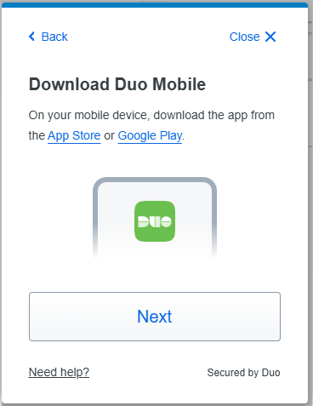
You will then be prompted to download the ‘Duo Mobile’ app from your relevant app store. If you already have the app downloaded please select “Next” to continue.

Step 6:

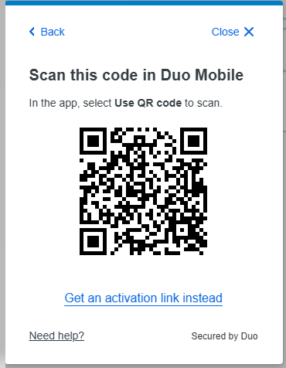
Open the ‘Duo Mobile’ App and click the ‘Add+’ option and then click ‘Use QR code’ to scan the QR code that is presented on your screen.
Step 7:

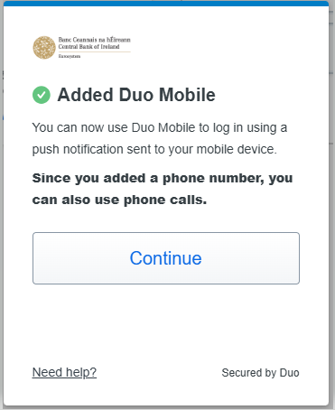
After you have scanned the QR code you will receive a confirmation message that you can use ‘Duo Mobile’ to log in. Click continue and you will be brought back to the main ‘Manage Devices’ screen.

Step 8:
You will receive a confirmation email from no-reply@duosecurity.com confirming that you have added a device. If the device was added by you, you do not need to take further action on the confirmation email.

If you receive this email and you did not add a device please click the option on the email ‘No, this wasn’t me’.

Below is a sample of the email confirmation. You will receive when adding a device.

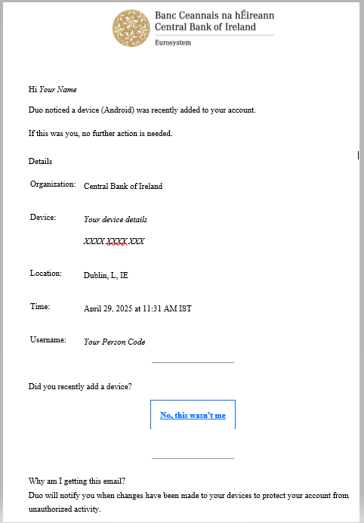

Test Portal

- Cisco-Duo has also replaced the Microsoft Authenticator on the test portal. Users that are unable to login to the test portal will get a ‘Not enrolled in Duo’ message and will need to email <onlinereturns@centralbank.ie>. You will then receive an email from <no-reply@duosecurity.com> that will contain a link for enrolment. This link will be valid for 30 days.

Troubleshooting.

- If you have lost access to the device that you have set up your second factor method on and you do not have an alternative second factor method set up you can contact onlinereturns@centralbank.ie. We recommend that you set up an alternative second factor method which you can do on enrolment or when you login and click ‘Other Options’ and selecting ‘Manage Devices’.

- If you are using the phone call method to authenticate and are not receiving the phone call when you sign in please check if your ‘Wi-Fi calling’ setting are turned on. If so please turn off your Wi-Fi calling setting. Some phone providers allow Wi-Fi to receive calls in areas with weak signal. If you have a weak mobile signal but strong Wi-Fi please use the ‘Duo Mobile’ app.

- The ‘Duo mobile’ app is supported on devices that run Android 12 and later and IOS 17 and later.

- Users will automatically be notified within the app if they are using an unsupported version of the DUO Mobile App ( Less than 4.85.0 ) otherwise they will fail authentication. Please see below appendix on how to check your Duo Mobile app version.

- Cisco Duo does not provide official support for non-standard custom Android operating systems like OnePlus, LineageOS, or ColorOS, nor is Duo Mobile supported for use on ChromeOS. The current version of ‘Duo Mobile’ supports Android 11 and greater.

- If you do not have a Smartphone, please select the ‘Phone call’ method.

- If you cannot find the ‘Duo Mobile’ app in your app store please select the ‘Phone call’ method.

- If you update your email address on the Central Bank Portal this does not automatically update your email address on Duo. Please email onlinereturns@centralbank.ie to request an update to your email on Duo and please include your person code, old email address and new email address.

- Please visit our portal help page ‘Second Factor Method’ for more information. https://www.centralbank.ie/regulation/central-bank-portal/help/help-on-your-second-factor-method

- For more information on Cisco Duo please visit - https://duo.com

Appendix
How to check what Duo Mobile app version you have installed.
To check the version of Duo Mobile on your device please open the duo mobile app menu as highlighted in red on the below screenshot.

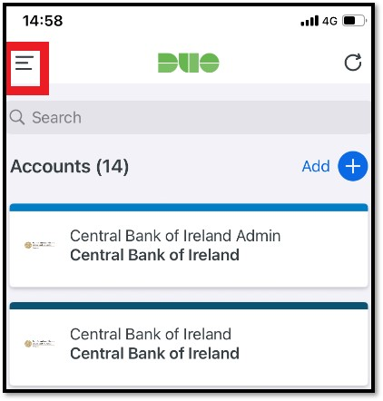

Once you have opened the menu you should see the version that you have downloaded as highlighted in the below image.

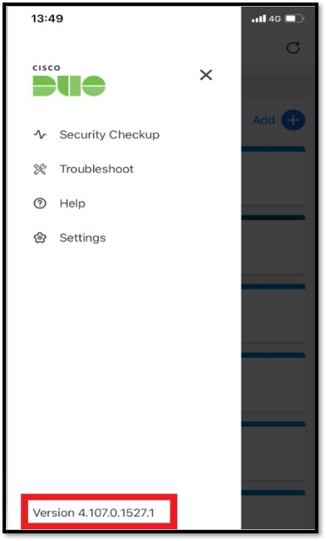
T: +353 (0)1 224 5800
E: publications@centralbank.ie
www.centralbank.ie

